

**“ BI-DIRECTIONAL VISITOR COUNTER”**

**A MINI PROJECT**

**REPORT**

*Submitted by*

**k.chandrika (1NH18EC048)**

***In partial fulfillment for the award of the degree of***

**BACHELOR OF ENGINEERING**

IN

**ELECTRONICS AND COMMUNICATION**

**ENGINERRING**

**NEW HORIZON COLLEGE OF ENGINEERING**

**DEPARTMENT OF ELECTRONICS AND**

**COMMUNICATION ENGINEERING**



**CERTIFICATE**

Certified that the mini project work entitled “**BI-DIRECTIONAL VISITOR COUNTER**” carried out by**, kamineni chandrika (INH18EC048)** bonafide students of Electronics and Communication Department, New Horizon College of Engineering, Bangalore.

The mini project report has been approved as it satisfies the academic requirements in respect of mini project work prescribed for the said degree.

Project guide HOD ECE

Mr. Deepak Kumar S Dr. Sanjeev Sharma

Senior Assistant Professor B. Tech M. Tech PhD

Dept of ECE NHCE

NHCE

------------------------- ------------------------

**External Viva**

Name of Examiner Signature with Date

1.

2.

**ACKNOWLEDGEMENT**

The satisfaction that accompany the successful completion of any task would be, but impossible without the mention of the people who made it possible, whose constant guidance and encouragement helped us succeed.

We thank **Dr. Mohan Manghnani**, Chairman of **New Horizon Educational Institution**, for providing necessary infrastructure and creating good environment.

We also record here the constant encouragement and facilities extended to us by **Dr. Manjunatha**, Principal, NHCE and **Dr. Sanjeev Sharma**, head of the department of Electronics and Communication Engineering. We extend sincere gratitude to them.

We sincerely acknowledge the encouragement, timely help and guidance to us by our beloved guide **Mr Deepak Kumar S** to complete the project within stipulated time successfully.

Finally, a note of thanks to the teaching and non-teaching staff of electronics and communication department for their co-operation extended to us, who helped us directly or indirectly in this successful completion of mini project.

**KAMINENI CHANDRIKA (INH18EC148)**

**TABLE OF CONTENT**

|  |  |  |
| --- | --- | --- |
| CHAPTER NUMBER | CHAPTER NAME | PAGE NUMBER |
| 1 | INTRODUCTION | 2-4 |
| 2 | LITERATURE SURVEY | 5 |
| 3 | EXISTING SYSTEM AND PROBLEM STATEMENT | 6 |
| 4 | PROPOSED SYSTEM | 7-14 |
| 5 | HARDWARE DESCRIPTION | 15-28 |
| 6 | RESULT AND DISSCUSSION | 29 |
| 7 | ADVANTAGES AND APPLICATIONS | 30 |
| 8 | CONCLUSION AND FUTURE SCOPE | 31 |
| 9 | REFERENCES | 32 |

**LIST OF FIGURES**

|  |  |  |  |
| --- | --- | --- | --- |
| **SL N0.** | **FIGURE NUMBER** | **FIGURE DESCRIPTION** | **PAGE NUMBER** |
| 1 | 4.1 | Circuit diagram of Bi-directional visitor counter | 7 |
| 2 | 4.2 | Step 1 to upload Arduino code | 12 |
| 3 | 4.3 | Step 2 to upload Arduino code | 13 |
| 4 | 5.1 | Arduino UNO | 16 |
| 5 | 5.2 | Pin diagram of Arduino UNO | 17 |
| 6 | 5.3 | Male to male jumper wire | 20 |
| 7 | 5.4 | Male tom female jumper wire | 21 |
| 8 | 5.5 | Female to female jumper wire | 21 |
| 9 | 5.6 | IR Sensor | 22 |
| 10 | 5.7 | IR Sensor pin diagram | 22 |
| 11 | 5.8 | LED | 23 |
| 12 | 5.9 | Photodiode | 24 |
| 13 | 5.10 | Working of IR Sensor | 24 |
| 14 | 5.11 | KY038 | 25 |
| 15 | 5.12 | LED | 26 |
| 16 | 5.13 | Resistor | 26 |
| 17 | 5.14 | Colour coding of resistor | 27 |
| 18 | 5.15 | USB a to USB b cable | 27 |
| 19 | 6.1 | Result | 29 |

**LIST OF TABLES**

|  |  |  |  |
| --- | --- | --- | --- |
| **SL N0.** | **TABLE NUMBER** | **TABLE DESCRIPTION** | **PAGE NUMBER** |
| 1 | 2.1 | Literature survey | 5 |
| 2 | 5.1 | Hardware requirement | 15 |
| 3 | 5.2 | Pin description of Arduino UNO | 19 |
| 4 | 5.3 | Technical specification of Arduino UNO | 19 |
| 5 | 5.4 | Pin description of IR Sensor | 23 |

**ABSTRACT**

There are many situations when we need to monitor the people visiting some place like Seminar halls, conference rooms or Shopping malls or temples etc... This project aim is to be used to count and display the number of people entering or going out any conference room or seminar hall. This is a bidirectional counter that means it works in a two way. This means counter value will be incremented if a person enters the room and will be decremented if a person goes out of the room. Serial Monitor is used to display this value. This system is very much helpful for counting the number of people in an auditorium or seminar halls to avoid congestion. Moreover this project can also be used to check the number of people who visited to an event or a museum to watch a certain exhibit. Microcontroller is very much reliable circuit that takes over counting the number of visitors in or out of the room with very much accuracy. We will be displaying both entry count i.e. number of people entering the room and exit count i.e. number of people exiting the room on Serial Monitor. IR sensor is used to detect the person entering and leaving the room. When any person enters into the room, count would be increased and on leaving count would decreased. IR sensing is the mechanism that is used to detect the entry & exit of visitors and the counting operation is done by the microcontroller. System will also count the number of claps by which light and fan are controlled. If a human is present in room and two claps are heard then fan would be turned on/off. Also if only one clap is heard then lights would be turned on/off to save electricity. Fan & light control is done by relay and sound sensor. Availability of visitor is available from counter value.

Therefore, system would take care of electricity and display count of visitors available in room.

**CHAPTER 1**

**INTRODUCTION**

In present world, there is a need of automatic appliances. With the increasing standard of living, there is an urgency for developing circuits that would make easy the complexity of life. Many times we need to monitor the people visiting some place like shopping mall, cinema halls. To provide solution for this we are going to implement a project called “Bi Directional Digital Visitor Counter” with automatic room light control by just clapping. This project has a “Visitor counter”.

Basic idea behind this project is to count and display the number of persons entering in and going out of any room like seminar hall, conference room etc. Count is displayed on serial monitor. We can use this project to count and display the number of visitors entering inside and going out of any conference room or seminar hall any shopping mall.

This project works in bidirectional way. Bidirectional means if person enters the room then counter will be incremented and will be decremented if any person goes out of the room. In addition, it will automatically control room lights by clapping with two hand. When the room is empty the lights will be automatically turn off as there is no one to clap. Digital Visitor Counter bidirectional visitor counter now a days it has mandatory need of automatic appliance will be increase in standard of living.

Also if someone wants to know the number of persons present in a room so as not to have congestion in the room, the circuit can prove to be helpful .The aim of this project when merged with certain established technologies can be more effective in number of countries like France & Japan etc.

This Project is useful in developing countries and this project has a bright future in next coming world. This project helps us to control the light of a room automatically by clapping and counts the number of visitors entering and leaving the room. By using this circuit and proper power supply we can implement various applications such as fans, tube lights by single clapping and double clapping.

Bidirectional visitor counter using Arduino UNO is a reliable circuit that takes over counting of number of Visitors in/out of the Room with very accuracy. If a visitor enters into the Room then the Counter is incremented by one and also leaves it would be decremented by one.

The total number of persons inside the Room is Shows on the serial monitor. Microcontroller does the job of receiving the signals from the sensors, and those signals are operated under the control of program which is stored in Arduino UNO.

There are two IR Modules used. One module can is used to count the number of persons entering a hall at the entrance gate. And the second one can count the number of persons leaving the hall by decrementing the count at the exit gate through sensors placed.

This Project will helps to get rid of Wastage of electricity. In our home, school, colleges or industry we see that fan and lighting point are kept on even if there is no one present in the room. This happens due to our negligence or because we forgot to turn off lights or fans or we are in a hurry.

To avoid all such kind of situations this project “Bi-directional visitor counter” is designed. This project has two tasks to be done, the first one is “Bi-directional Visitor counter” and the second one is known as “Automatic room light controller by clapping”.

The main concept behind this project is known as “Visitor counter System” which measures the number of persons entering any room like a conference room, hotel rooms, seminar hall, shopping malls. This Bi-directional visitor counter project is implemented using IR sensor module with Arduino UNO. Arduino UNO receives the data that is required from the sensors, and this data is operated under the control of program which is stored in the Microcontroller.

The main intention of Bi-directional visitor counter project is to design a system where the count of persons entering or going out of the room is kept track of and displayed on a screen or serial monitor.

When a person goes into the room, count will be increased, whereas on going out of the room, the count will be decreased. IR sensing is the mechanism that is used to sense the presence of visitors and the whole counting operation is done by a microcontroller present in the circuit.

This Bi-directional visitor circuit works on the principle of IR sensing. In IR Sensors IR LED works as Infrared Light Source and a Photo Detector like a Photo Diode acts as a Transmitter and Receiver respectively when a person enters and leaves.

In Bi-directional visitor counter project, we have used an IR LED as IR Transmitter and Photo Diode as IR Receiver. Pair of IR sensors that consists an IR LED and Photo Diode are placed at the entrance of a room to count the number of persons.

Output data from each IR sensor is sent to the Arduino UNO. In normal situation, IR light that emitted from the IR LED would not fall on the Photo Diode as it is a Reflective type IR Sensor. The output from the IR sensor would be of logic LOW signal in the case.

In case of any interruption, the Photo Diode would receive the IR Light reflected and start conducting. So, the output from the IR sensor would be logic HIGH signal.

The transition from low to high or high to low in each IR sensor pair is detected by the Arduino UNO and accordingly count will be increased or decreased.

**CHAPTER 2**

**LITERATURE SURVEY**

|  |  |  |
| --- | --- | --- |
| Title of the paper | Author & year of publications | Outcome |
| International journal of scientific and Research publications | Volume 6,issue7,July 2016,ISSN2250-3153 | Energy can be saved and used more efficiency |
| Modelling and using imperfect context information | Henricksen.K,  J.Indulska(2004) | Energy can be saved and used more efficiecy |
| Implementing wireless networks | Nemzow.M(1995) | Furnishing wireless servieces |
| Simulation of the energy efficient bidirectional visitor counting | S.M.Tanvir siddiquee(1999) | Saves the energy |
| Birectional digital visitor or  Person counter | Smit Babriya  July7 (2019) | It will determine max number of visitors |
| Clap switch using sound sensor | S.Sai Surya Teja  June 4,2018 | Switch on lights and fans by clapping |

Table-2.1 Literature Survey

**CHAPTER 3**

**PROBLEM STATEMENT AND EXISTING SYSTEM**

**3.1 PROBLEM STATEMENT:-**

Bi-Directional Visitor Counter with clap switch

**OBJECTIVES:-**

* The aim of our project is to make a controller which can sense if any person enters the room and it lights up the room automatically.
* It also counts how many person are entering the room or going out of it.
* It is made to prevent unwanted electric power waste in schools, colleges, offices and houses.
* This whole process is operated automatically by its sensors.

**3.2 EXISTING SYSTEM:-**

* During earlier days, there used to be someone who opens and closes the door when one wants to enter or exit.
* Earlier lighting systems used to contain switch and one needs to turn on switches manually.
* Earlier there needs to be someone who needs to keep count on people entered into the room.
* We need to go near switch board to turn on/off lights and fans.Before one need to be there at homes and other places to keep a check on the number of persons entering and exit the room. There will be wastage of electricity, if anyone forgets to switch off any light or fan.
* But now, all the above scenario has a single solution. That is project Bi-Directional Visitor Counter.

**CHAPTER 4**

**PROPOSED SYSTEM**

Our proposed system is an Arduino based system. Arduino UNO interfaced with IR sensor and sound sensor together makes this project. IR detection property of IR sensors is used to detect human movement. Two IR sensors are used to count the entry and exit of humans. If any person entered then counts increments by one. And if any person exits then count is decremented. Sound sensor (KY 038) is used to detect if any sound is produced using claps or not. And through Arduino IDE program, we made a logic in such a way that single clap is used to control light. And double clap is used to control fan. After that all data is displayed on serial monitor.

**4.1 CIRCUIT DIAGRAM AND WORKING:-**

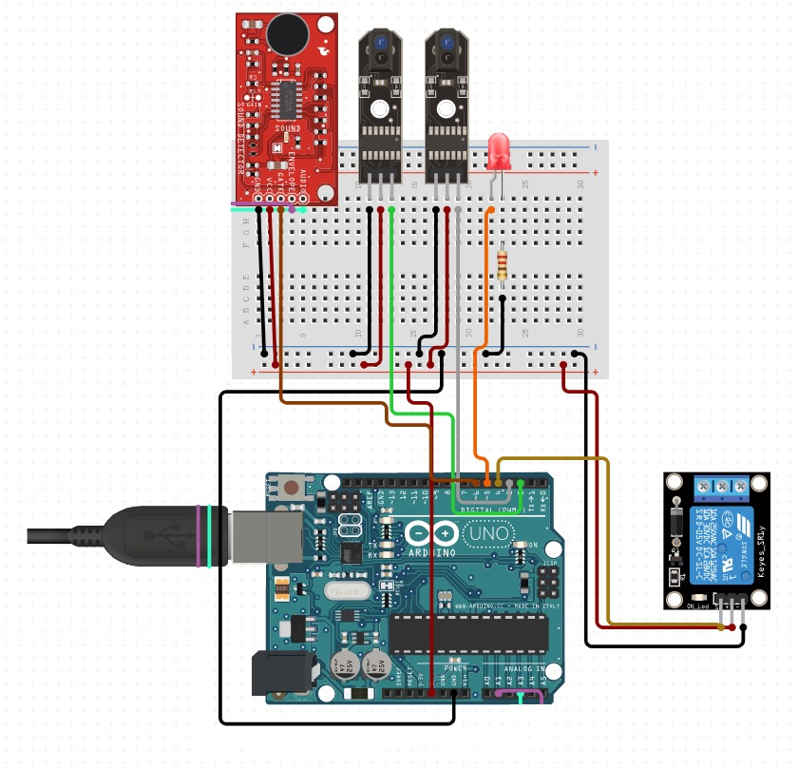

Fig-4.1 Circuit Diagram of Bi-Directional visitor counter

* Arduino uno is a micro controller with atmega 328p as micro processor.
* We use the concept of IR sensing to detect human movement.
* Ir sensor is a digital sensor which gives output as either high or low.
* We have connected this ir sensor to digital i/p pins of arduino.
* Two ir sensors are used, one detects person entered and other detects persons exit.
* When ir sensor detects any movement it sends output to digital pin.
* When ever arduino receives high it increments the count.
* And total is calculated as number of person entered - number of person exit
* If the total is greater than zero, then sound sensor checks for claps.
* This sound sensor can be used as analog sensor or digital sensor, but we are using it as digital sensor.
* It is connected to digital i/o pin of arduino.
* When ever it detects clap it sends output high to arduino.
* And when ever arduino receives high, it counts number of claps
* If claps are one, then light is turned on/off.
* If claps are two, then fan is turned on /off
* And then total data is displayed on serial monitor which is an in built feature of arduino ide

**4.2 ARDUINO CODE :-**

int i=0,j=0,s=0;

boolean fan=0,light=0;

void setup() {

pinMode(2,INPUT); //ir sensor 1

pinMode(3,INPUT); // ir sensor 2

pinMode(6,INPUT);// sound sensor ky 038

pinMode(4,OUTPUT); // fan

pinMode(5,OUTPUT);// light

Serial.begin(9600);

digitalWrite(5,light);

digitalWrite(4,fan);

}

void loop() {

int l=digitalRead(2);

int m=digitalRead(3);

if(l==1)

{

i++;

s++;

}

if(m==1)

{

if(s!=0)

{

s--;

j++;

}

}

int a=digitalRead(6);

if(a!=0)

{

delay(400);

int b=digitalRead(6);

if(a!=0 && b==0)

{

light=!light;

digitalWrite(5,light);

}

else if(a!=0 && b!=0)

{

fan=!fan;

digitalWrite(4,fan);

}

}

Serial.print("Number of persons entered :");

Serial.print(i);

Serial.print(" Number of persons exit: ");

Serial.print(j);

Serial.print(" total number in house: ");

Serial.println(s);

if(fan==HIGH)

{

Serial.println("Fan is ON");

}

else

{

Serial.println("Fan is OFF");

}

if(light==HIGH)

{

Serial.println("Light is ON");

}

else

{

Serial.println("Light is OFF");

}

delay(1000);

}

**4.2.1 STEPS TO UPLOAD CODE :-**

* Select Board “Arduino UNO” by following the path Tools 🡪Board🡪 Arduino UNO.
* Then connect the arduino board to your laptop via arduino cable.
* Then click on compile and check if there are any errors.If no errors then click on “ 🡪 ” to upload code onto arduino board.

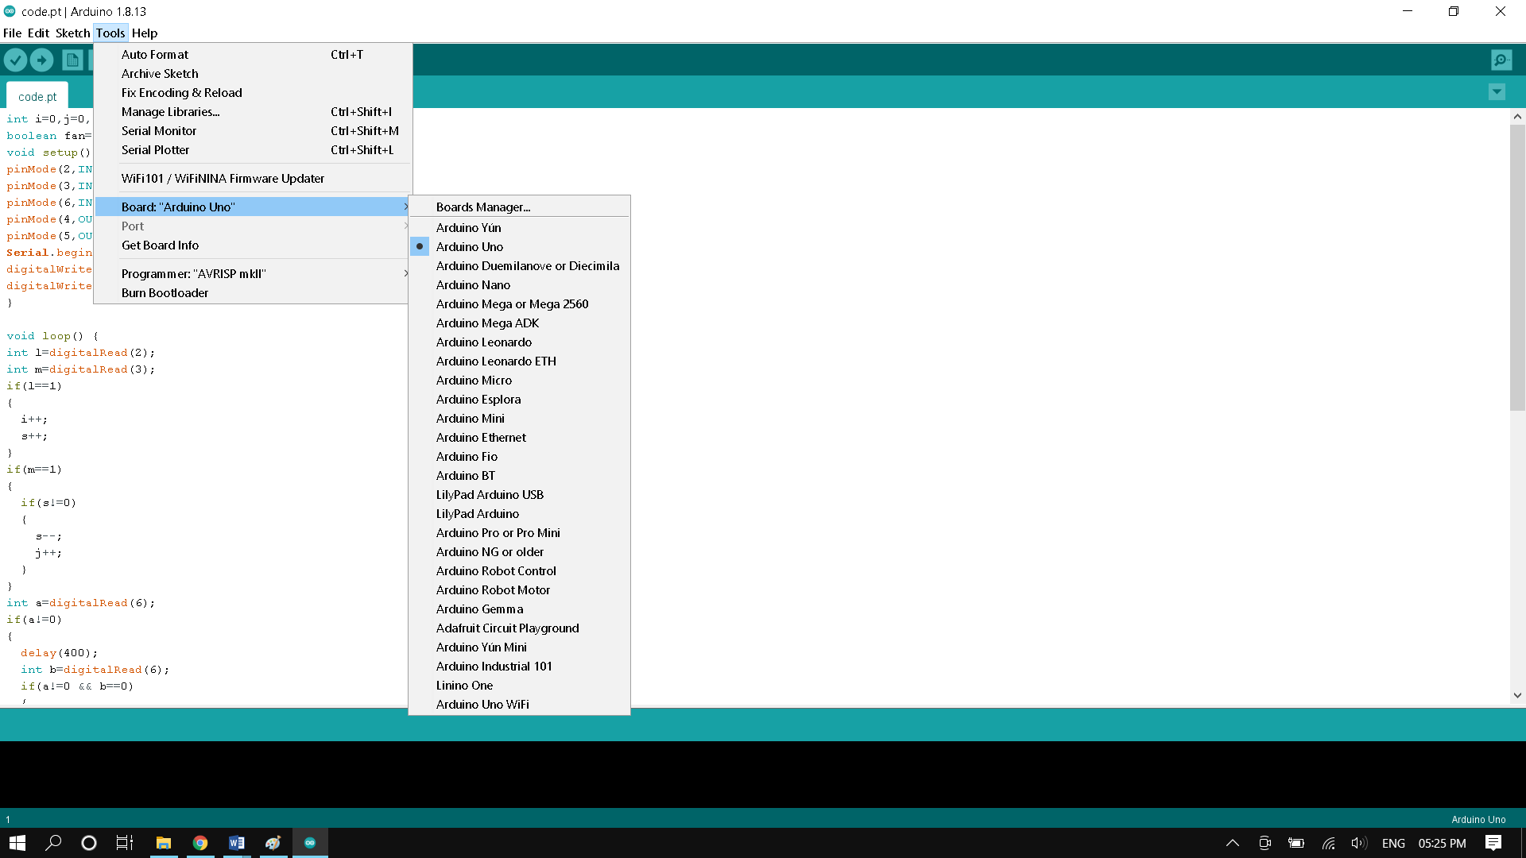

Fig-4.2 Step 1 to upload code

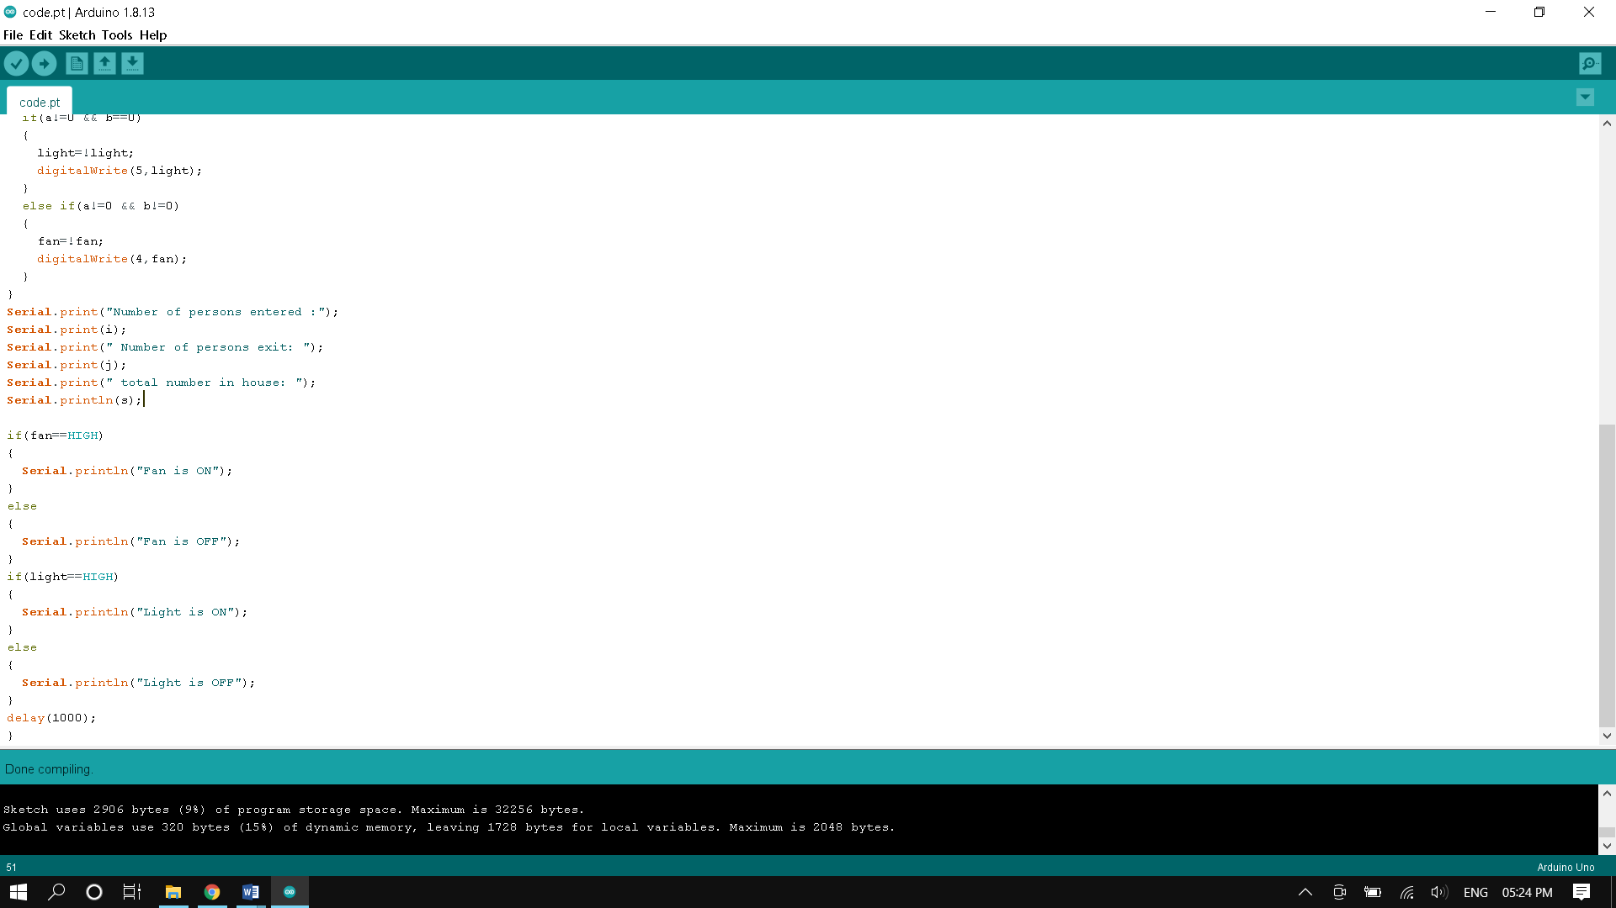

Fig-4.3 Step 2 to upload code

**4.2.2 Code Explanation:-**

* The code snippet written in void setup( ) function will execute only once and that when the arduino board is reset or restarting.
* Only the code written in void loop( ) function will execute infinite times unless the arduino board is reset or turned off.
* First we are declaring three variables i , j , s and initializing to zero.
* Here i denotes number of persons entering room, j denotes number of persons going out of room and s denotes number of persons present in room.
* Then void setup( ) is executed for the first time.
* In this we are declaring digital i/o pins 2,3 as input pins to arduino.
* These 2 pins are connected to data pins of 2 IR sensors.
* pinMode( ) takes two arguments where first argument is pin number and second argument is pinmode whether it is input or output.
* Here we are using serial monitor to display the status of the room.
* So we are writing Serial.begin(9600) where 9600 is the baudrate to connect arduino with serial monitor.
* Now void loop( ) will starts it’s executing for the first time.
* digitalRead( ) takes only argument where argument is the pin number.
* It returns boolean values 1 or 0 depending on the input it received from the specified pin number.
* Pin number 2 is used to count number of people entered the room and pin number 3 is used to count number of people went out of the room.
* Pin number 6 is used to count the number of claps.
* Pin number 4 is used to control fan and pin number 5 is used to control light.
* When the counting part is done, it’s time to print the output on serial monitor.
* If number of claps are one, then light is turned on/off.
* If number of claps are two, then fan is turned on/off.
* Serial.print( ) and Serial,println( ) are used to print data on serial monitor.
* Difference between Serial.print( ) and Serial.println( ) is println adds a new line character after displaying the message in it.
* After printing data on serial monitor we are giving delay (1000).
* Delay( ) function takes only one arguemnt. It takes number of milli seconds as an argument and keeps the program on hold for that time.
* And this void loop( ) is executed infinite times until power is turned off or reset is enabled.

**CHAPTER 5**

**HARDWARE DESCRIPTION**

The components required are as follows:-

**5.1 HARDWARE REQUIREMENT:-**

|  |  |  |
| --- | --- | --- |
| **SL NO** | **COMPONENTS** | **NUMBER OF COMPONENTS** |
| **1** | **Arduino Uno** | **1** |
| **2** | **Jumper wires** | **As required** |
| **3** | **IR sensors** | **2** |
| **4** | **KY 038 (sound sensor)** | **1** |
| **5** | **LED** | **1** |
| **6** | **Resistor (1k**Ω) | **1** |
| **7** | **USB a to USB b cable** | **1** |
| **8** | **Relay** | **1** |
| **9** | **Breadboard** | **1** |

Table-5.1 Hardware Requirement

**5.2 SOFTWARE REQUIREMENT:-**

* **Arduino IDE**

A detailed explanation about these elements are given as follows for better understanding of the circuit.

**5.1.1 ARDUINO UNO :-**

The Arduino Uno is an open-source microcontroller. It is based on the Microchip ATmega328P which is developed by Arduino.cc. Arduino UNO board is equipped with a set of digital and analog I/O pins that can be interfaced to several other boards and other circuits. This Arduino UNO board has 6 analog input pins, 14 digital input pins (out of which six pins are capable of PWM output) and are programmable with the Arduino IDE via a type b USB cable. It can also be powered by the USB cable or by a 9-volt external battery, though it’s acceptable voltage range is 7-20 volts. Instead of pressing a reset button physically before an upload, Arduino UNO board is designed such that it allows it to be reset by software running on connected to a computer. One hardware flow control line (DTR) of ATmega8U2/16U2 is connected to the reset line of the ATmega328 using a 100 nano farad capacitor. When it is low on this line, the reset line drops long enough to reset the chip.

This setup has several other allegations too. When the Arduino UNO is connected to a computer that has Mac OS X or Linux as its operating system, it resets every time a USB connection is made to it from software. For the following half-second, the boot loader is running on the Arduino UNO. It is programmed such that it ignores anything besides an upload of new code, it will intercept the first few bytes of data sent to the UNO board after a connection is opened.

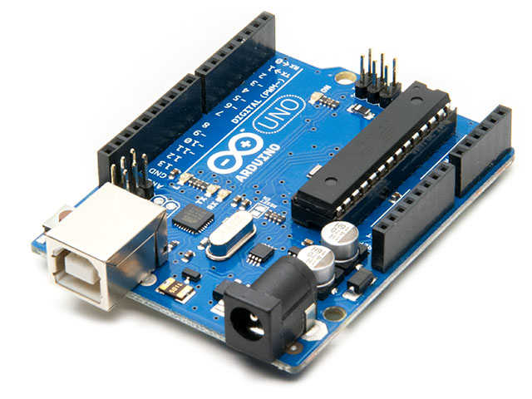

Fig-5.1 Arduino UNO

**PIN DIAGRAM:-**

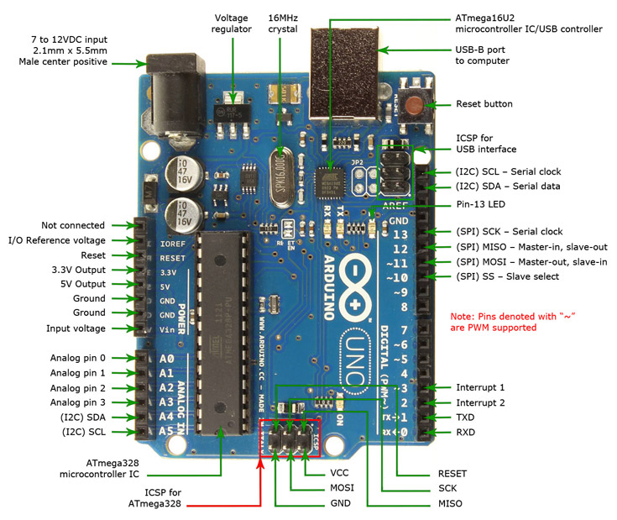

Fig-5.2 Pin Diagram of Arduino UNO

**PIN DESCRIPTION:-**

|  |  |  |
| --- | --- | --- |
| Pin Category | Pin Name | Details |
| Power | Vin, 3.3V, 5V, GND | Vin: Input voltage to Arduino when using an external power source.  5V: Regulated power supply used to power microcontroller and other components on the board.  3.3V: 3.3V supply generated by on-board voltage regulator. Maximum current draw is 50mA.  GND: ground pins. |
| Reset | Reset | Resets the microcontroller |
| Analog Pins | A0 – A5 | Used to provide analog input in the range of 0-5V |
| Input/output pins | Digital Pins 0-13 | Can be used as input or output pins |
| Serial | 0(Rx), 1(Tx) | Used to receive and transmit TTL serial data |
| External interrupts | 2,3 | To trigger an interrupt |
| PWM | 3, 5, 6, 9, 11 | Provides 8-bit PWM output |
| SPI | 10 (SS), 11 (MOSI), 12 (MISO) and 13 (SCK) | Used for SPI communication |
| Inbuilt LED | 13 | To turn on the inbuilt LED |
| TWI | A4 (SDA), A5 (SCA) | Used for TWI communication |
| AREF | AREF | To provide reference voltage for input voltage. |

Table-5.2 Pin Description of Arduino UNO

**TECHNICAL SPECIFICATIONS:-**

|  |  |
| --- | --- |
| microcontroller | Microchip ATmega328P |
| Operating Voltage | 5 Volts |
| Input Voltage | 6 to 20 Volts |
| Digital input pins | 14(6 can provide PWM output) |
| Analog input pins | 6(A0-A5) |
| DC current on input pins | 20 mA |
| DC current on 3.3V pin | 50 mA |
| Flash Memory | 32KB (0.5 KB is used for bootloader) |
| SRAM | 2 KB |
| EEPROM | 1 KB |
| Frequency (clock speed) | 16MHz |
| length | 68.6mm |
| width | 53.4mm |
| weight | 25g |

Table-5.3 Technical Specifications of Arduino UNO

**5.1.2 JUMPER WIRES:-**

A jumper wire is associate electrical wire incorporates a connector or pin at each end that we have a tendency to use it to interconnect the components of a breadboard or test circuit, internally or with any other tools or components, without soldering them. Individual jumper wires are fixed by presenting the connector ends inserted into the slots provided in a breadboard, the header connector of a circuit board, or into a part of test equipment.

The jumper wires are typically of three types:

These jumper wires are categorized into three types based on their end of the wire. Basically, the male tip has a protruding end which is used to plug into things whereas, the females do not have protruding ends and cannot be used to plug into things.

* **The male-to-male:**

This is the most common type of jumper wire that we are using quite often. Our project also involves the use of this male-to-male type of jumper wires. To be more specific, while connecting two ports on a breadboard a male-to-male wire is useful.

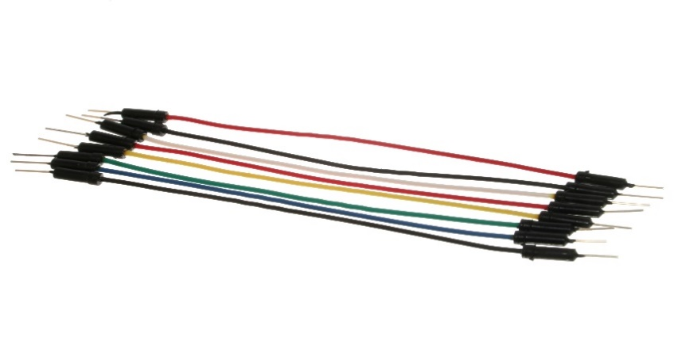

Fig-5.3 Male to male jumper wires

* **Male-to-female:**

Male-to-female jumper wires are very much used while connecting female header pin of a board to any other development board with a male connector.

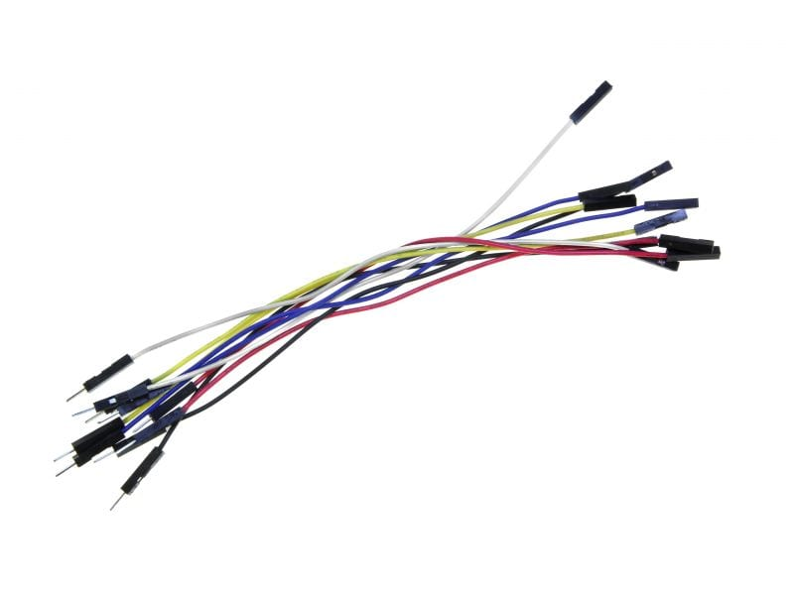

Fig-5.4 Male to female jumper wires

* **Female-to-female:**

Female-to-Female jumper wires are very much useful for making wire hardness on printed circuit boards.

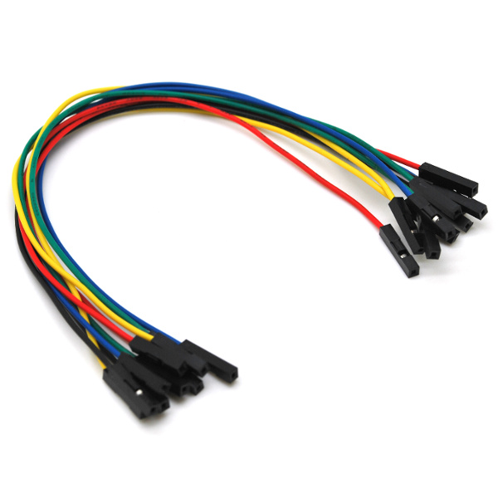

Fig-5.5 Female to female jumper wires

The male ends are designed such that they can be inserted into standard 0.1 inch female sockets, while the female ends are designed so that they can be inserted onto standard 0.1 inch male headers.

These are used in Arduino based projects, breadboard kit project, PCB project, pc motherboard etc.

**5.1.3 IR SENSORS:-**

IR Sensor modules have higher proficiency of the ambient light, having a pair of infrared transmitter and a receiver tube, infrared emitter tube is to emit a particularfrequency, when came across an obstacle detection direction (reflecting surface), infrared radiation reflects back to the receiver tube. After processing it by a comparator circuit, green LED glows, while the signal output will be a digital signal (a low-level signal), using the potentiometer knob we can change the detection range, while the effective distance range is 2-10cm, and the working voltage range is 3.3V-5V. Detection range of the IR sensor are often varied by rotating the potentiometer, with a little amount of interference, easy to gather, easy to use abilities, are widely used in robot obstacle dodging, obstacle hinderance automotive production line and black&white line tracking and many other occasions as well.

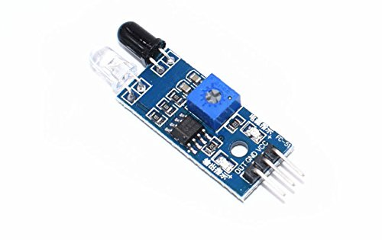

Fig-5.6 IR Sensor

**PIN DIAGRAM:-**

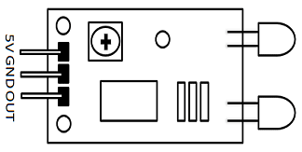

Fig-5.7 Pin Diagram of IR Sensor

**PIN DESCRIPTION**:-

|  |  |
| --- | --- |
| Pin name | Description |
| VCC | Power Supply input |
| GND | Power Supply Ground |
| OUT | Active High Output |

Table-5.4 Pin Description of IR Sensor

**WORKING PRINCIPLE:-**

Infrared transmitters can be varied into different types based on their wavelengths, response time and output power. An IR sensor circuit consists of an IR LED and a Photodiode, both together called as Photo Coupler or Opto Coupler.

**IR Transmitter or IR LED**

Infrared Transmitter is an light emitting diode which emits infrared radiations called as IR LED’s. Even though an IR LED looks like a normal LED, the radiation emitted by it is of IR wavelength and is invisible to the human eye.

The picture of an Infrared LED is shown below.

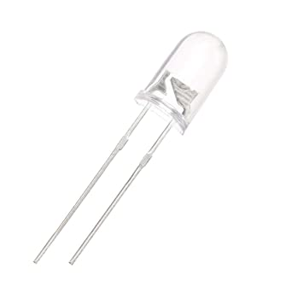

Fig-5.8 LED

**IR Receiver or Photodiode**

Infrared receivers detect the radiation from an IR LED which are also known as IR transmitters. IR receivers are available in the form of photodiodes and phototransistors. Infrared Photodiodes are different from that of normal photo diodes as they are capable of detecting only infrared radiation. Below image shows the picture of an IR receiver or a photodiode.

[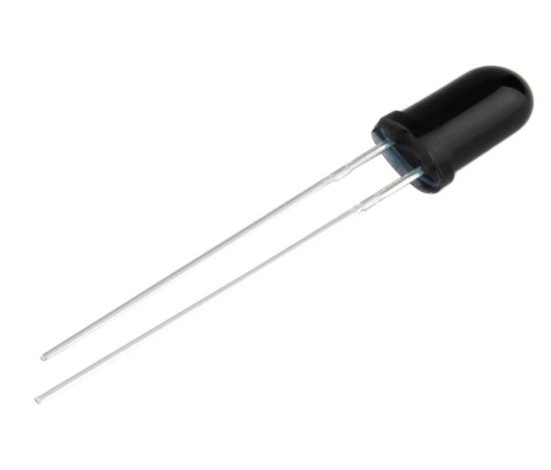](https://aws.robu.in/wp-content/uploads/2020/05/SN-IR-R-0-1-1-800x800-1.jpg)

Fig-5.9 Photodiode

IR receivers are differentiated into different types based on the wavelength, package, voltage etc. When used as infrared trans receiver, the wavelength of the receiver should also match with that of the IR transmitter.

The emitter is an IR LED and the detector is an IR photodiode. IR photodiode is sensitive to the IR light which is emitted by an IR LED. Photo-diode’s resistance and output voltage varies in proportion to the IR light received.

[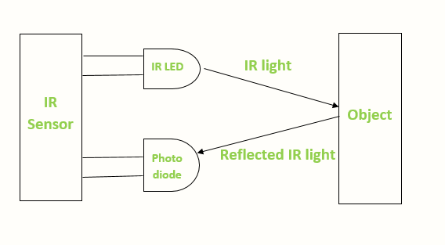](https://aws.robu.in/wp-content/uploads/2020/05/IR-sensor-Working.png)

Fig-5.10 Working of IR Sensor

When IR transmitter emits IR radiation, it reaches the object and some amount of the radiation transmitted is reflected back to the IR receiver. Based on the intensity of the radiation received by the IR receiver, the output of the sensor is defined.

**5.1.4 KY 038 (SOUND SENSOR):-**

* The ky-38 sound sensor is a very basic level sound detector module which has an electric condenser microphone. It is a part of sensor kit that is available to be purchased and the main part of this sound sensor module is an LM393 comparator. There are 2 onboard LEDs, one is used to indicate power and the other is used to indicate when the sensor reaches a certain value.
* The KY 038 sensor has 2 outputs
* AO, It is an analog output, it gives real-time output voltage signal of the condenser microphone
* DO, when the intensity of sound reaches a certain value, the output goes high else low

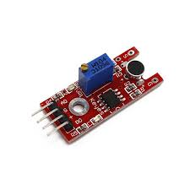

Fig-5.11 KY038

**5.1.5 LED:-**

Light-emitting diode is a semiconductor device that emits light when it is supplied with electric current. Light is produced when electrons and holes combine together within the semiconductor material.

As light is generated in solid semiconductor material, LEDs can also be described as solid-state devices. Term solid-state lighting, encompasses organic LEDs which in short known as OLEDs, distinguishes lighting technology from other sources that use heated filaments or gas discharge.

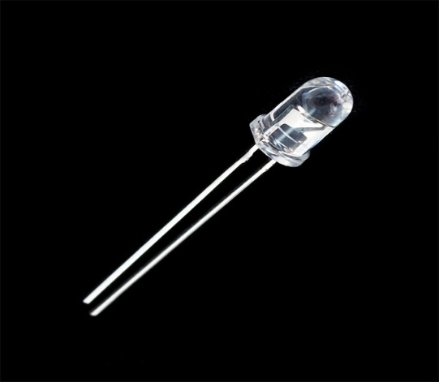

Fig-5.12 LED

**5.1.6 RESISTOR:-**

Value of resistor that we used in our circuit is 1kΩ. Resistor is a two-terminal device which are often used in electric circuits and provides specific resistance to the flow of current in the circuit. Resistance of a resistor can be linear or non-linear depending on the application it is being used. Resistance of a linear resistor is self-determined of voltage applied. Whereas the resistance of a non-linear resistor changes with the voltage applied. Resistors that are made of semi-conductor are non-linear. Resistors can be used to control the amount of provided voltage to part of a circuit and to help create timing circuits.

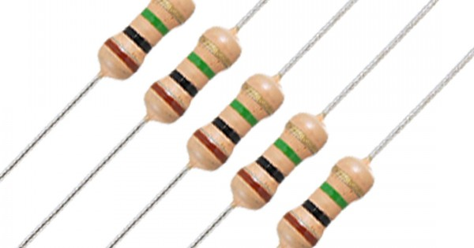

Fig-5.13 Resistor

Colour coding used in resistors is to calculate the magnitude of the resistance in ohms. Colour coding is a process which is widely used in calculating the value of the resistors. The colour bands on the resistor are of very significant while calculating the value of the resistors. Each colour has a unique resistance value along with some tolerance value as shown in the figure mentioned below.

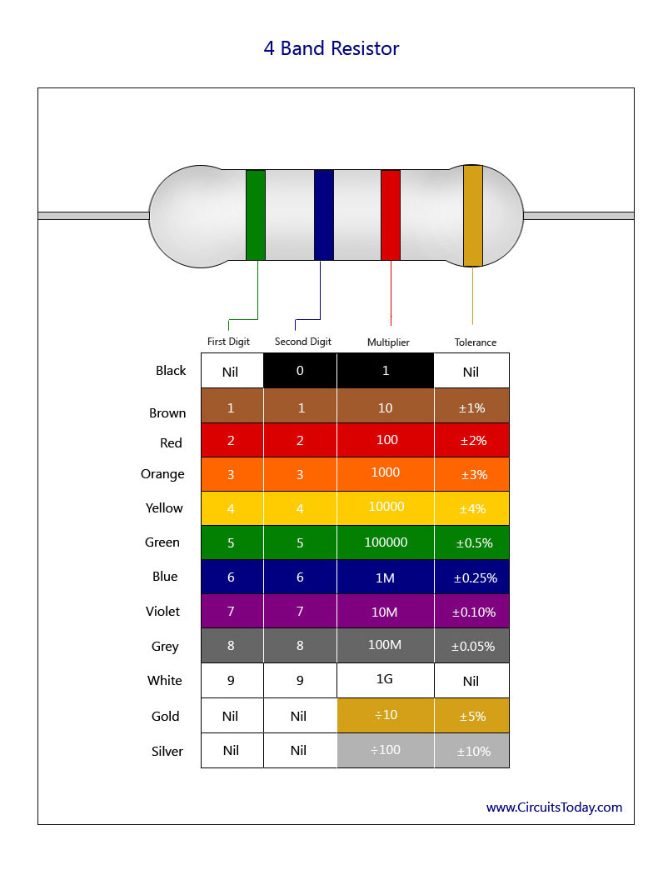

Fig-5.14 Colour coding of resistors

**5.1.7 USB A to USB B CABLE:-**

This is a cable used for Arduino UNO/MEGA (USB A to B)-1feet, one can use it to connect Arduino or any board with the USB female A port of computer. Length is approximately 0.52 metres. Cable colour and cable shape may vary slightly from image.



**Fig-5.15 USB a to USB b cable**

**5.2 ARDUINO IDE:-**

IDE stands for “Integrated Development Environment” .It is a software that is officially introduced by Arduino.cc which is mainly used for writing, editing, compiling and uploading the code in the Arduino Device. Almost all Arduino modules are compatible with this Arduino IDE software and is available to install and start compiling the code on the go applications.

* Arduino IDE is an open source software that is mainly used for writing, editing and compiling the code into the Arduino Module.
* It is an official Arduino software, making code compilation too easy that even a common person even with no technical knowledge can get with the learning process.
* It is easily available for operating systems like MAC, Windows, and Linux and runs on the Java Platform that comes with inbuilt functions and commands that play a vital role for debugging, editing and compiling the code in the environment.
* 4.A range of Arduino modules available including Arduino Uno, Arduino Mega, Arduino Leonardo, Arduino Micro and many more.
* Each of them contains a microcontroller on the board that is actually programmed and accepts the information in the form of code.
* The main code, also known as a sketch, created on the IDE platform will ultimately generate a Hex File which is then transferred and uploaded in the controller on the board.
* 7.The IDE environment mainly contains two basic parts: Editor and Compiler where former is used for writing the required code and later is used for compiling and uploading the code into the given Arduino Module.
* 8. This environment supports both C and C++ languages.

**CHAPTER 6**

**RESULT AND DISSCUSSION**

* The IR sensor continuously senses the presence of any obstacles (a person in our case).
* If sensor 1 senses a person, it informs the controller that a person has entered so that controller can increment the count.
* At the same time it gives a delay of 1sec so that the person can cross the sensor 2 and the count is maintained correctly.
* When a person exits, the sensor 2 informs the controller to decrement the count.
* Similarly it also provides a delay of 1 sec to maintain count properly.
* The count is displayed on serial monitor by the controller.
* If there is at least 1 person is inside the room, and single clap will turn on/off the light and double clap will turn on/off the fan.

**CHAPTER 7**

**ADVANTAGES AND APPLICATIONS**

**7.1 ADVANTAGES:-**

* This can be used for automatic room light control.
* It will help to save electricity.
* When no one is there in room the appliances will be off.
* In School/companies it will help to check if somebody is there in the zone or not.
* If the data on display unit is zero the security guards can shut the gate easily.
* There will be so much of power that can be consumed because of this.

**7.2 APPLICATIONS:-**

* Count at Shopping Malls entrances
* Count at Temples, holy places
* Count at Tourist places
* Count at official meetings
* To count the number of persons entering the party
* Home security systems
* Home automation systems

**CHAPTER 8**

**CONCLUSION AND FUTURE SCOPE**

**8.1 CONCLUSION:-**

In demonstration of the project, the infrared sensing part used to detect the passage of visitors worked. Microcontroller was very efficient in its task performance, thus computation of counts and controlling I/O devices. Hence the whole purpose of the bidirectional visitor counter was successfully achieved and is applicable in the wider scope.

Finally, we conclude that the proposed system will count visitors effectively and efficiently by reducing the rate at which error occurs when counting visitors. As the project was to design and construct a device that would count and display the exact number of people in a building, the following recommendation however should be considered to ensure effective operation of the digital bidirectional visitor counter.

The sensors should be positioned at the entrance in a way not to attract visitor’s attention. The device should be installed at a narrow entrance suitable for only one person to pass through at a given time. An uninterruptible power supply should be introduced to the system to serve as a backup power supply. In the near future, some institutions that deem it necessary to monitor their crowd may no longer rely solely on human auditors and unsophisticated counter systems to tally the number of visitors.

**8.2 FUTURE SCOPE:-**

This circuit can be used domestically to get an indication of number of persons entering a party. It can be used at homes and other places to keep a check on the number of persons entering a secured place. It can also be used as home automation system to ensure energy saving by switching on the loads and fans only when needed.

**REFERENCES**

[1] S. M. Mohaiminul Islam; Dept. of Computer Science, South Asian Univ., New Delhi, India ; Md. Mahbub-E- Noor, S. M. Tanvir Siddiquee Simulation of energy efficient Bi-directional Visitor Counting Machine.

[2] [www.arduino.cc](http://www.arduino.cc/)

[3] http://circuitdigest.com/microcontroller- projects/automatic-room-light-controller-with- bidirectional-visitor-counter-using-arduino

[4] <http://www.datasheetcafe.com/ky-038-pdf-arduino/>

[5] <https://www.elprocus.com/infrared-ir-sensor-circuit-and-working/>

[6] <https://en.wikipedia.org/wiki/Arduino_Uno>

[7] <https://components101.com/microcontrollers/arduino-uno>

[8] https://www.researchgate.net/publication/328615543_Integrated_Development_Environment_IDE_For_Arduino